Alexander Cannell

4/10/2014

Week 4 activity 1

* ASSOC: Display or change the association between a file extension and a fileType
* CD: Change Directory
* Chkdsk: Check Disk - check and repair disk problems
* CMD: Start a new CMD shell and (optionally) run a command/executable program.
* Date: Display or change the date.
* Dir: Display a list of files and subfolders
* echo: Display messages on screen, turn command-echoing on or off.
* help: Online help for MS Windows - most commands will give help when run with /? or -? (COMMAND /? or COMMAND -?)
* Hostname: Display the host name portion of the full computer name of the computer.
* Ipconfig: Configure IP (*internet protocol* configuration)
* md: Make Directory - Creates a new folder.
* msinfo32: System Information - display details about hardware configuration, computer components, software and drivers.
* Net: The NET Command is used to manage network resources as follows:
* Netstat: Display current TCP/IP network connections and protocol statistics.
* nslookup: Lookup IP addresses on a NameServer.
* openfiles: Query or display open files, disconnect files opened by network users.
* Path: Display or set a search path for executable files
* ping: Test a network connection - if successful, ping returns the ip address.
* RD: Delete folder(s)
* Systeminfo: List system configuration
* Taskkill: End one or more processes (by process id or image name).
* TaskList: displays all running applications and services with their Process ID (PID) This can be run on either a local or a remote computer.
* Time: Display or set the system time.
* Vol: Display the volume label of a disk.
* where: Locate and display files in a directory tree.
* whoami: Display user, group and privileges for the current user.

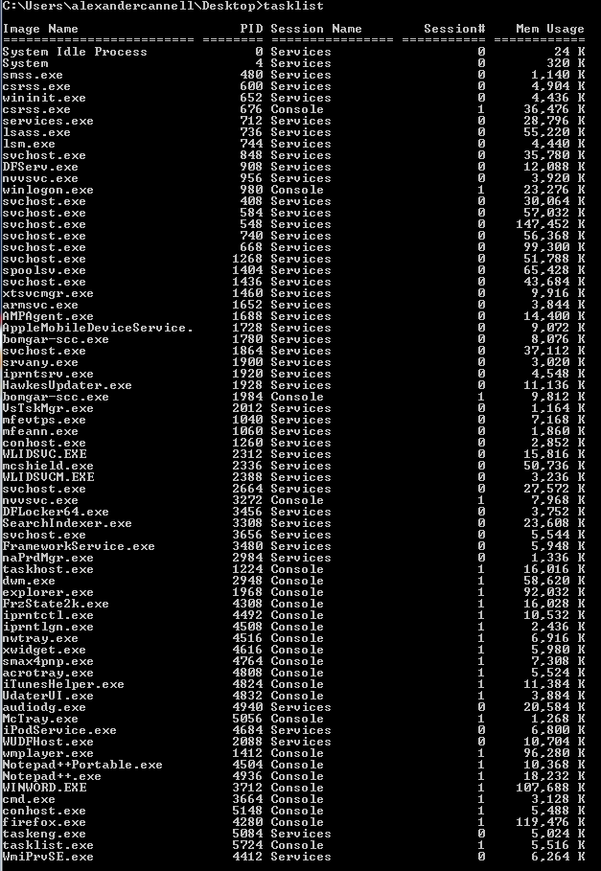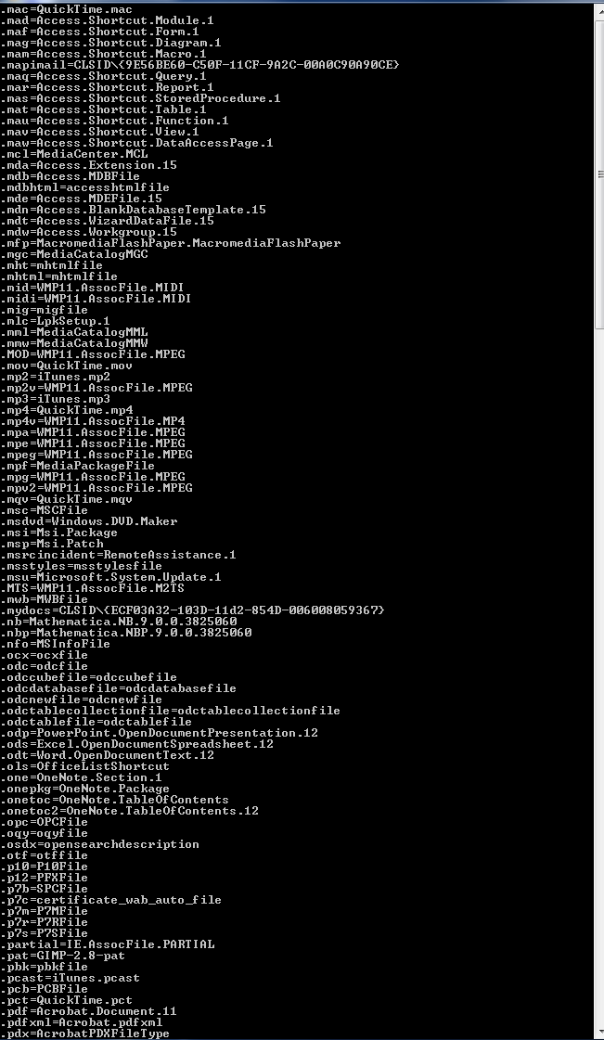C:\Users\Alexander\Desktop\week04\cd.PNG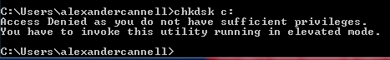C:\Users\Alexander\Desktop\week04\cmd.PNGC:\Users\Alexander\Desktop\week04\date.PNG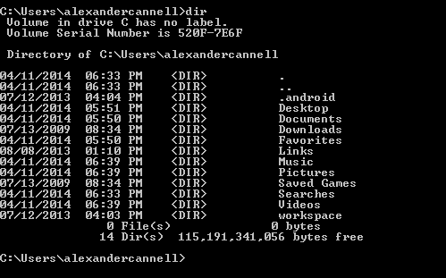C:\Users\Alexander\Desktop\week04\echo.PNG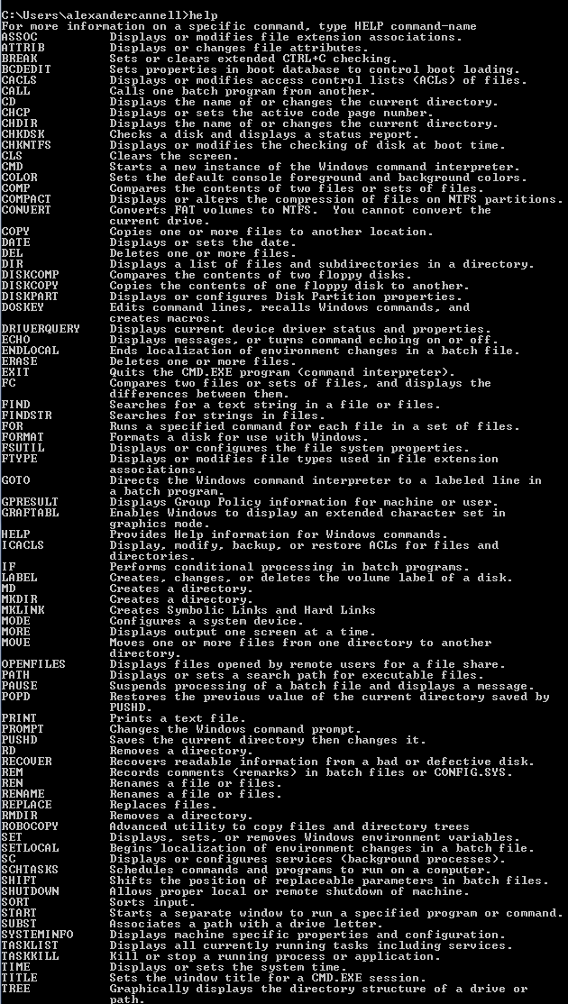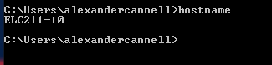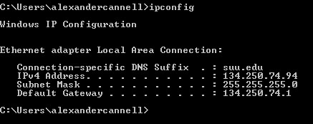C:\Users\Alexander\Desktop\week04\md.PNG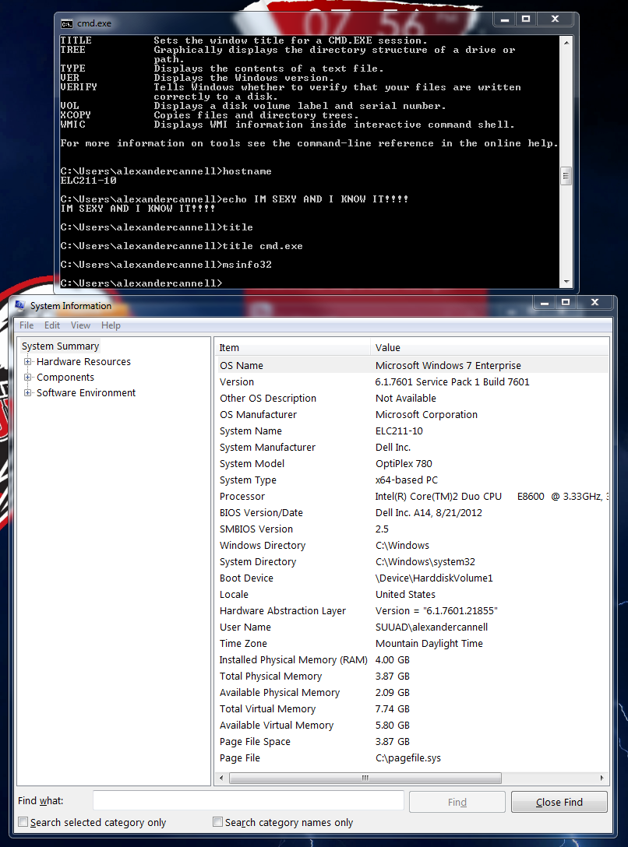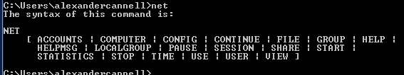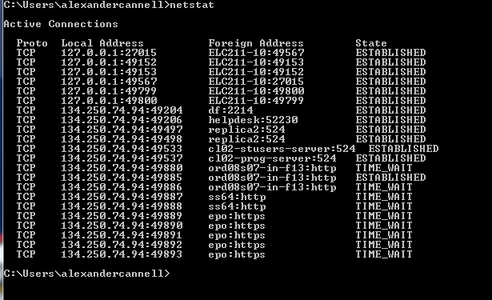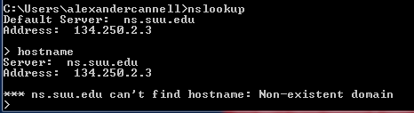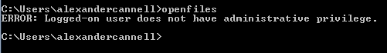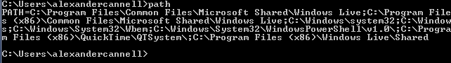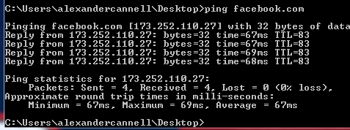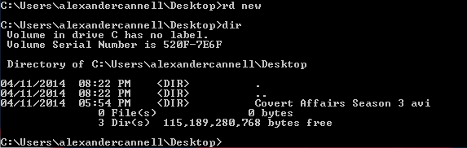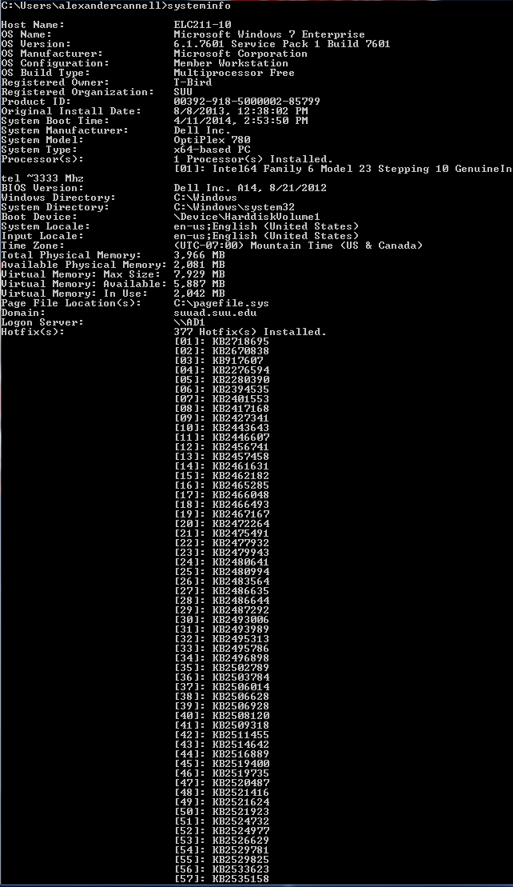C:\Users\Alexander\Desktop\week04\taskkill.PNG

C:\Users\Alexander\Desktop\week04\time.PNG